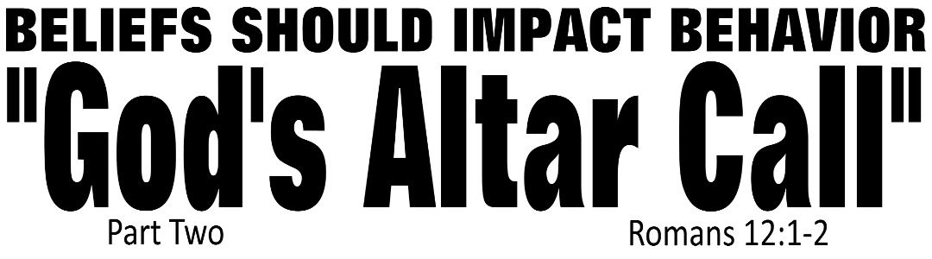

Dr. Joe K. Taylor, Senior Pastor, South Reno Baptist Church, Reno, NV November 1, 2015
All Scriptures are printed verbatim with translations noted. Pew Bible Page Number is 1045.
In the Study Verse Section, God’s Word is printed in regular faced text with Pastor Joe’s commentary in the smaller faced text.
Biblical words, underlined with dots, are explained in the brackets. Pastor Joe’s email is Joe@southreno.com

1. We must present our bodies to God.
2. If you consider all that God has done for you—a sinful being—the only reasonable response you have is to present Him with your whole life.
3. “God is ready to assume full responsibility for the life that is totally yielded to Him.” - Andrew Murray
4. In the end times, the church will be overwhelmed by apostasy and the society will collapse into anarchy/immorality and people with develop apathy—not loving God or their fellow man.

“Be Transformation—not Conformed!”
Romans 12:1–2, NCV - ¹ So brothers and sisters, since God has shown us great mercy, I beg you to offer your lives as a living sacrifice to him. Your offering must be only for God and pleasing to him, which is the spiritual way for you to worship. ² Do not be shaped by this world; instead be changed within by a new way of thinking. Then you will be able to decide what God wants for you; you will know what is good and pleasing to him and what is perfect.
The Bible says that the end time will be a time of Affliction.
Matthew 24:9-10, NLT - ⁹ “Then you will be arrested, persecuted, and killed. You will be hated all over the world because you are my followers. ¹⁰ And many will turn away from me …..

Romans 12:1–2, PME - ¹ With eyes wide open to the mercies of God, I beg you, my brothers, as an act of intelligent worship to give Him your bodies, as a living sacrifice, consecrated to Him and acceptable by Him. ² Don’t let the world around you squeeze you into it’s own mold, but let God remake you so that your whole attitude of mind is changed. Thus you will prove in practice that the will of God is good, acceptable to Him and perfect.
God’s Altar Call
Part Two—Romans 12:2

1. Present your ____ to God.

2. Present your ____________ to God.

STUDY VERSE SECTION - Romans 12:2, HCSB - ² Do not be conformed [Gk: συσχηματίζω (sys-cha-ma-TEEZE-oh) lit., “to be molded or stamped according to a pattern”; it’s in passive voice implying that if you don’t actively and intentionally resist this ‘age’, you will be conformed to it] to this age [Gk: αἰών, (i-own), is not a reference to planet earth—rather a world system or philosophy; eg., anything goes, tolerance is in, absolute truth is out, etc.], but be transformed [Gk: μεταμορφόω, (meta-mor-PHO), which forms our English word “metamorphosis;” Note: It’s in present tense—this is not an on-again, off-again transformation, but a continuous one ; this verb is in passive voice—implying the catalyst for transformation is God, not you; and it’s in imperative mood—indicating we do need to take responsivity because this must get done] by the renewing [Gk: ἀνακαίνωσις (ana-ka-nosis) means “to reestablish something to a like-new and improved state;” we get our English word “renovate” from it] of your mind, so that you may discern what is the good, pleasing, and perfect [the Gk. word means that which has reached its end, therefore, it is complete in itself, lacking nothing; once you’ve discovered it, you will never want to add a thing to the] will of God.
3. Present your ____________ over to God.
Romans 12:2, NLT - ² Don’t copy the behavior and customs of this world, but let God transform you into a new person by changing the way you think. Then you will learn to know God’s will for you, which is good and pleasing and perfect.

“Be Transformed—not Conformed!”
A. What we are to offer—whole body dedication.
B. What we are to avoid—worldly contamination.
C. What we are to achieve—Godly transformation.
If the world controls your thinking, you’ll be a conformer; if God controls your thinking, you’ll be a transformer.

Life Application Section

1. Are you saved—have you presented your whole being over to God?
2. Is your mind being renewed by the transforming power of the Word?
3. Have you discovered and surrendered to the will of God for your life?

