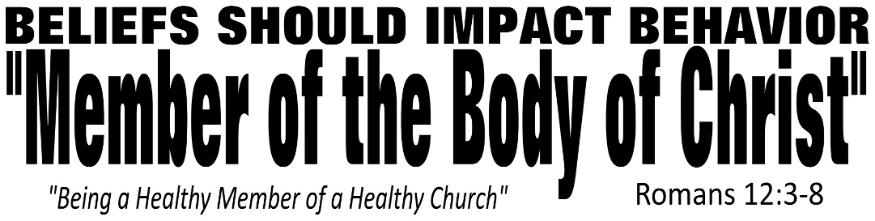

Dr. Joe K. Taylor, Senior Pastor, South Reno Baptist Church, Reno, NV January 10, 2016
All Scriptures are printed verbatim with translations noted. Pew Bible Page Number is 1045-1046.
In the Study Verse Section, God’s Word is printed in regular faced text with Pastor Joe’s commentary in the smaller faced text.
Biblical words, underlined with dots, are explained in the brackets. Pastor Joe’s email is Joe@southreno.com

1. Romans 12 give four metaphors of what the believer’s life is like:
That of a Sacrifice on an Altar
That of a Part of a Body
That of a Member of a Family
That of a Soldier in an Army
2. Romans 12:1 - Sacrifice on an Altar - If you consider all that God has done for you—a sinful being—the only reasonable response you have is to present Him with your whole life. (It’s “God’s Altar Call.”)
3. Romans 12:2 – If the world controls your thinking, you’ll be a conformer; if God controls your thinking, you’ll be a transformer.

Traits of a Healthy Member in the Healthy Body:
1. Eliminated Distractions.
Romans 12:1–2, GNB - ¹ So then, my brothers and sisters, because of God’s great mercy to us I appeal to you: offer yourselves as a living sacrifice to God, dedicated to his service and pleasing to him. This is the true worship that you should offer. ² Do not conform yourselves to the standards of this world, but let God transform you inwardly by a complete change of your mind. Then you will be able to know the will of God—what is good and is pleasing to him and is perfect.
Many love the church but they don’t have time for it.
2. Honest Evaluation.
Romans 12:3, HCSB - ³ For by the grace given to me, I tell everyone among you not to think of himself more highly than he should think. Instead, think [Paul uses the Gk. word translated “think” four different times in four different ways in this one verse*] sensibly, as God has distributed a measure of faith to each one.
*Romans 12:3, (lit.) – “Do not super-think of yourself more highly than you ought to think, but rather think of yourself with sober thinking.”
“Humility is knowing who you are and who you’re not in Christ.”
3. Faithful Cooperation.
Romans 12:4–5, HCSB - ⁴ Now as we have many parts in one body, and all the parts do not have the same function, ⁵ in the same way we who are many are one body in Christ and individually members of one another.
The body has many parts—visible and invisible.
Every part of the body is important.
Every part of the body depends on every other part.
4. Individual Participation.
Romans 12:6–8, HCSB - ⁶ According to the grace given to us, we have different gifts: If prophecy, [the ability to speak authoritative truth of God], use it according to the standard of one’s faith; ⁷ if service, [the ability to provide practical help to meet the needs of others], in service; if teaching, [the ability to understand and communicate God’s Word in a clear and relevant manner], in teaching; ⁸ if exhorting, [the ability to encourage, comfort, confront, and instruct others], in exhortation; giving, [all Christians are commanded to give generously but those with this gift excel ‘single mindedly’ in the gift of giving] with generosity; leading [the ability of motivate, coordinate, and oversee others in ministry], with diligence; showing mercy, [the ability to perceive people’s hurts and gently and lovingly console them] with cheerfulness.
Every believer has at least one spiritual gift
No believer has all the gifts
Your spiritual gift enables you to serve the body of Christ effectively.
Life Application Section

A. Focus of your own spiritual transformation daily.
B. Focus on your dominant spiritual gift.
C. Seek to equip an apprentice. (“There is no success without a successor.”)
D. Refuse to procrastinate in service.
Transformed Christians should realistically assess the gifts God has given them, then use those gifts as part of Christ’s body—the Church.

Dr. Joe K. Taylor, Senior Pastor, South Reno Baptist Church, Reno, NV January 10, 2016
All Scriptures are printed verbatim with translations noted. Pew Bible Page Number is 1045-1046.
In the Study Verse Section, God’s Word is printed in regular faced text with Pastor Joe’s commentary in the smaller faced text.
Biblical words, underlined with dots, are explained in the brackets. Pastor Joe’s email is Joe@southreno.com

1. Romans 12 give four metaphors of what the believer’s life is like:
That of a Sacrifice on an Altar
That of a Part of a Body
That of a Member of a Family
That of a Soldier in an Army
2. Romans 12:1 - Sacrifice on an Altar - If you consider all that God has done for you—a sinful being—the only reasonable response you have is to present Him with your whole life. (It’s “God’s Altar Call.”)
3. Romans 12:2 – If the world controls your thinking, you’ll be a conformer; if God controls your thinking, you’ll be a transformer.

Traits of a Healthy Member in the Healthy Body:
1. Eliminated Distractions.
Romans 12:1–2, GNB - ¹ So then, my brothers and sisters, because of God’s great mercy to us I appeal to you: offer yourselves as a living sacrifice to God, dedicated to his service and pleasing to him. This is the true worship that you should offer. ² Do not conform yourselves to the standards of this world, but let God transform you inwardly by a complete change of your mind. Then you will be able to know the will of God—what is good and is pleasing to him and is perfect.
Many love the church but they don’t have time for it.
2. Honest Evaluation.
Romans 12:3, HCSB - ³ For by the grace given to me, I tell everyone among you not to think of himself more highly than he should think. Instead, think [Paul uses the Gk. word translated “think” four different times in four different ways in this one verse*] sensibly, as God has distributed a measure of faith to each one.
*Romans 12:3, (lit.) – “Do not super-think of yourself more highly than you ought to think, but rather think of yourself with sober thinking.”
“Humility is knowing who you are and who you’re not in Christ.”
3. Faithful Cooperation.
Romans 12:4–5, HCSB - ⁴ Now as we have many parts in one body, and all the parts do not have the same function, ⁵ in the same way we who are many are one body in Christ and individually members of one another.
The body has many parts—visible and invisible.
Every part of the body is important.
Every part of the body depends on every other part.
4. Individual Participation.
Romans 12:6–8, HCSB - ⁶ According to the grace given to us, we have different gifts: If prophecy, [the ability to speak authoritative truth of God], use it according to the standard of one’s faith; ⁷ if service, [the ability to provide practical help to meet the needs of others], in service; if teaching, [the ability to understand and communicate God’s Word in a clear and relevant manner], in teaching; ⁸ if exhorting, [the ability to encourage, comfort, confront, and instruct others], in exhortation; giving, [all Christians are commanded to give generously but those with this gift excel ‘single mindedly’ in the gift of giving] with generosity; leading [the ability of motivate, coordinate, and oversee others in ministry], with diligence; showing mercy, [the ability to perceive people’s hurts and gently and lovingly console them] with cheerfulness.
Every believer has at least one spiritual gift
No believer has all the gifts
Your spiritual gift enables you to serve the body of Christ effectively.
Life Application Section

A. Focus of your own spiritual transformation daily.
B. Focus on your dominant spiritual gift.
C. Seek to equip an apprentice. (“There is no success without a successor.”)
D. Refuse to procrastinate in service.
Transformed Christians should realistically assess the gifts God has given them, then use those gifts as part of Christ’s body—the Church.

