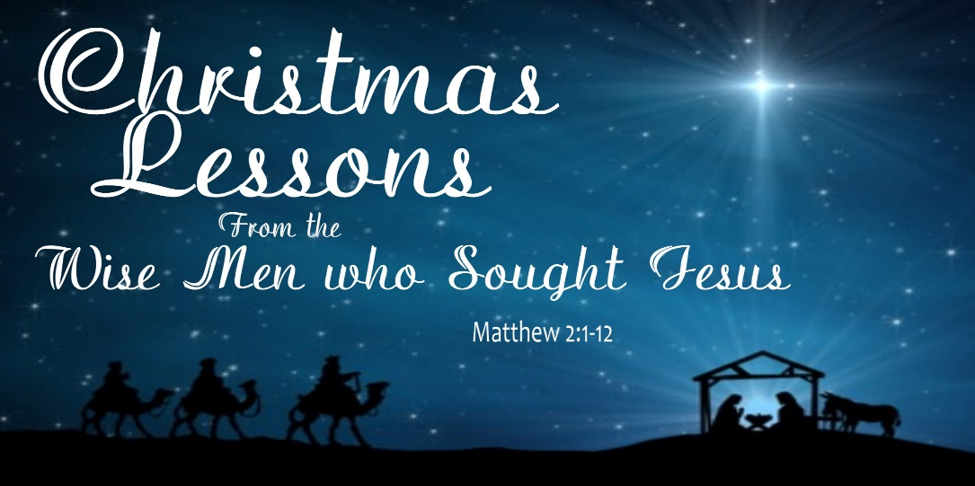
Dr. Joe K. Taylor, Senior Pastor, South Reno Baptist Church, Reno, NV Sunday, December 21, 2014
All Scriptures are printed verbatim with translations noted.

- Joseph’s life was marred by tragedy and marked by a task
- May we never forget that it is from the wreckage of our greatest hurts that God often builds us up for His greatest blessings.

F
ew biblical stores are as well known , yet so clouded by myth and tradition, as that of the magi, or wise men, mentioned by Matthew. During the Middle Ages, legend developed that they were kings, three in number, named Casper, Balthazar and Melchior. – Dr. John MacArthur,

Wise Men Still Seek Him

1. Wise men still approach Jesus.
Matthew 2:1–2, HCSB - ¹ After Jesus was born in Bethlehem of Judea in the days of King Herod, wise men from the east arrived unexpectedly in Jerusalem, ² saying, “Where is He who has been born King of the Jews?

2. Wise men still adore Him
Matthew 2:2, HCSB - ² “Where is He who has been born King of the Jews? For we saw His star in the east and have come to worship Him.” … ¹¹ Entering the house, they saw the child with Mary His mother, and falling to their knees, they worshiped Him.

3. Wise Men still adorn Him.
Matthew 2:11, HCSB - ¹¹ Entering the house, they saw the child with Mary His mother, and falling to their knees, they worshiped Him. Then they opened their treasures and presented Him with gifts: gold, frankincense, and myrrh.
A Fitting Gift of GOLD—The Gift for a King
A Foretelling Gift of FRANKINCENSE—The Gift for Priest
A Foreordained gift of MYRRH—The Gift for the Savior
A Forgotten Gift of WORSHIP—The Gift for the Lord

4. Wise men still acknowledge Him.
Matthew 2:12, HCSB - ¹² And being warned in a dream not to go back to Herod, they returned to their own country by another route.

Life Application Section

A. We must ____________ to God’s messenger (and obey).
Matthew 2:12, HCSB - ¹² And being warned in a dream not to go back to Herod, they returned to their own country by another route.

Luke 2:10–11, HCSB - ¹⁰ But the angel said to them, “Don’t be afraid, for look, I proclaim to you good news of great joy that will be for all the people: ¹¹ Today a Savior, who is Messiah the Lord, was born for you in the city of David.
“The angel said….

B. We must ____________ Jesus with haste.
Luke 2:15–16, NKJV – ¹⁵ So it was, when the angels had gone away from them into heaven, (they)…said to one another, “Let us now go to Bethlehem and see this thing that has come to pass, which the Lord has made known to us.” ¹⁶ And they came with haste and found Mary and Joseph, and the Babe lying in a manger.

C. We must make ____________ for Jesus.
Luke 2:7, NASB95 - ⁷ And she gave birth to her firstborn son; and she wrapped Him in cloths, and laid Him in a manger, because there was no room for them in the inn.

Answers to “Christmas Lessons—Wise Men” Sermon
Dr. Joe K. Taylor, Senior Pastor, South Reno Baptist Church, Reno, NV Sunday, December 21, 2014

A. Listen
B. Seek
C. Room

