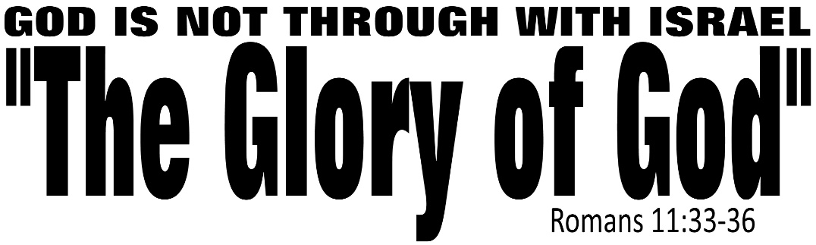

Dr. Joe K. Taylor, Senior Pastor, South Reno Baptist Church, Reno, NV October 18, 2015
All Scriptures are printed verbatim with translations noted. Pew Bible Page Number is 1045.
In the Study Verse Section, God’s Word is printed in regular faced text with Pastor Joe’s commentary in the smaller faced text.
Biblical words, underlined with dots, are explained in the brackets. Pastor Joe’s email is Joe@southreno.com

1. God has a plan for Israel that involved His great mercy.
2. God is not through with Israel-God chosen people.
3. Not every Jew of all time will be saved—only those who trust in Christ.
4. Modern Israel of today is a fulfillment of biblical prophecy.
5. Apostasy—moving away from God’s Holy Word: “What if we take away the cool music and the cushioned chairs? What if the screens are gone and the stage is no longer decorated? What if the air conditioning is off and the comforts are removed? Would His Word still be enough for His people to come together?” - David Platt, Radical
6. Romans 11: “The Grace of God” (vv. 1-10); “The Grafting of God” (vv. 11-24) ; and “The Guarantee of God” (vv. 25-32)

Paul gives a threefold doxology about God:
1. His ____________________.
Romans 11:33–34, HCSB - ³³ Oh, the depth of the riches both of the wisdom and the knowledge of God! How unsearchable His judgments and untraceable His ways! ³⁴ For who has known the mind of the Lord? Or who has been His counselor?
Isaiah 55:8–9, HCSB - ⁸ “For My thoughts are not your thoughts, and your ways are not My ways.” This is the Lord’s declaration. ⁹ “For as heaven is higher than earth, so My ways are higher than your ways, and My thoughts than your thoughts.
2. His ____________________.
Romans 11:35, HCSB - ³⁵ Or who has ever first given to Him, and has to be repaid?
Romans 11:35, GNB - ³⁵ Who has ever given him anything, so that he had to pay it back?”
Romans 11:35, PME – To whom is God a debtor?
Ephesians 2:8–9, NASB95 - ⁸ For by grace you have been saved through faith; and that not of yourselves, it is the gift of God; ⁹ not as a result of works, so that no one may boast.
3. His ____________________.
Romans 11:36, HCSB - ³⁶ For from Him and through Him and to Him are all things. To Him be the glory forever. Amen.
Romans 11:36, NLT - ³⁶ For everything comes from him and exists by his power and is intended for his glory. All glory to him forever! Amen.
Glory: Gk: δόξα (dox-za), “The manifest presentation of God’s infinite and majestic nature; normally conveyed to humanity as a holy radiance accompanied by spellbinding splendor and greatness.” (BDAB)
Historical Note: The Essenes (the copiers of Holy Scripture) were afraid of even writing this word δόξα so they coined the word, Shekhinah, to represent God’s glory in all its fullness. (The word is typically translated as ‘praise’ or ‘honor’.
1 Corinthians 10:31, NIV84 - ³¹ So whether you eat or drink or whatever you do, do it all for the glory of God.
Whatever you do, do it all for the glory of God!

The Bible says that the end time will be a time of Apostasy.
The Bible says that the end time will be a time of Anarchy.
Matthew 24:6-8, NLT - ⁶ And you will hear of wars and threats of wars, but don’t panic. Yes, these things must take place, but the end won’t follow immediately. ⁷ Nation will go to war against nation, and kingdom against kingdom. There will be famines and earthquakes in many parts of the world. ⁸ But all this is only the first of the birth pains, with more to come.

Answers: 1. Greatness, 2. Grace, 3. Glory

