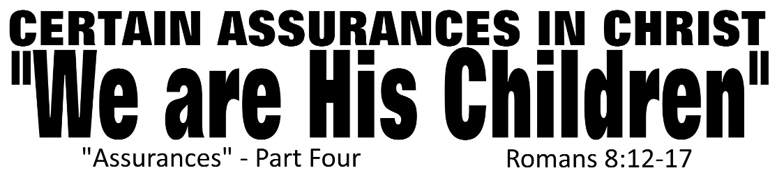

Dr. Joe K. Taylor, Senior Pastor, South Reno Baptist Church, Reno, NV February 1, 2015
All Scriptures are printed verbatim with translations noted. Pew Bible Page Number is 1041.
In the Study Verse Section, God’s Word is printed in regular faced text with Pastor Joe’s commentary in the smaller faced text.
Biblical words, underlined with dots, are explained in the brackets.

1. If Christ is in us, things change: Spiritually, the present changes as His Spirit lives in us right now. Physically, things will change as one day our dead bodies will be raised from the dead in a perfect state.
2. True believers can have the settled confidence of eternal life for three reasons: (1) Direct statements from the Word of God; (2) The Witness of the Holy spirit of God; and (3) Their will be an outward evidence of an inward change.
3. As a follower of Christ, you can be certain that you will live eternally with God for all eternity in a perfect place called Heaven.

F
or by grace you have been saved through faith; and that not of yourselves, it is the gift of God; ⁹ not as a result of works, so that no one may boast. ¹⁰ For we are His workmanship, created in Christ Jesus for good works, which God prepared beforehand so that we would walk in them. - Ephesians 2:8–10, NASB95
F
or I am confident of this very thing, that He who began a good work in you will perfect it until the day of Christ Jesus. - Philippians 1:6, NASB95

A gentle reminder…

Romans 8:12–13, HCSB - ¹² So then, brothers, we are not obligated to the flesh to live according to the flesh, ¹³ for if you live according to the flesh, you are going to die. But if by the Spirit you put to death the deeds of the body, you will live.

Romans 8:12–13, NCV - ¹² So, my brothers and sisters, we must not be ruled by our sinful selves or live the way our sinful selves want. ¹³ If you use your lives to do the wrong things your sinful selves want, you will die spiritually. But if you use the Spirit’s help to stop doing the wrong things you do with your body, you will have true life.
Four Benefits of Being His Child:

1. His Leading
Romans 8:14, HCSB - ¹⁴ All those led by God’s Spirit are God’s sons.
Romans 8:14, NCV - ¹⁴ The true children of God are those who let God’s Spirit lead them.

2. Fearless Intimacy
Romans 8:15, HCSB - ¹⁵ For you did not receive a spirit of slavery to fall back into fear, but you received the Spirit of adoption [Gk: υἱοθεσία, huiothesía (“huio” meaning “a child”; “thesia” meaning “to set apart as your own” Quote: “The irrevocable proceeding that creates parent-child relation between persons not related by blood; with the adopted child being entitled to all privileges belonging to a natural child including both the right to inherit and to refer to the father as abba…the Louw-Nida origin pictures “God holding His own child in His arms.” (The Lexham Analytical Lexicon to the Greek New Testament) Note: Paul uses the word 5 times: Rom. 8:15, 23, 9:4; Gal. 3:26 and Eph. 1:5], by whom we cry out, “Abba [(Aramaic) in informal but intimate term that a child would use to refer to their ‘daddy’], Father!” [(Greek) a little for formal use of the title, this refers to his headship (ie., source) with the home of over the individual.]

Romans 8:15, NLT - ¹⁵ So you have not received a spirit that makes you fearful slaves. Instead, you received God’s Spirit when he adopted you as his own children. Now we call him, “Abba, Father.”

3. His Assurance
Romans 8:16, HCSB - ¹⁶ The Spirit Himself testifies together with our spirit that we are God’s children…

Romans 8:16, TLB - ¹⁶ For his Holy Spirit speaks to us deep in our hearts and tells us that we really are God’s children.

4. A reminder of our value to God
Romans 8:17, HCSB - ¹⁷ and if children, also heirs —heirs of God and coheirs with Christ—seeing that we suffer with Him so that we may also be glorified with Him.
Romans 8:17, NLT - ¹⁷ And since we are his children, we are his heirs. In fact, together with Christ we are heirs of God’s glory. But if we are to share his glory, we must also share his suffering [ie., following Christ will not always be easy].
As a follower of Christ, you can be certain that you are (and always will be) a child of God.

