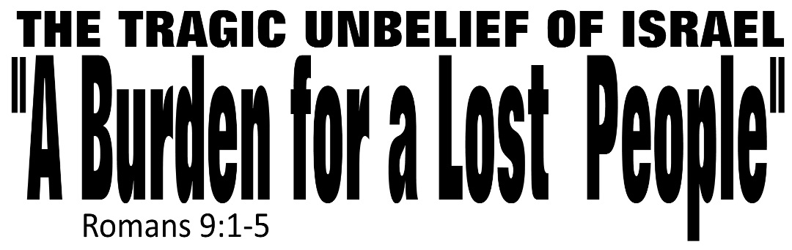

Dr. Joe K. Taylor, Senior Pastor, South Reno Baptist Church, Reno, NV June 7, 2015
All Scriptures are printed verbatim with translations noted. Pew Bible Page Number is 1042.
In the Study Verse Section, God’s Word is printed in regular faced text with Pastor Joe’s commentary in the smaller faced text.
Biblical words, underlined with dots, are explained in the brackets.

C
hristianity can be condensed into four words: Admit, Submit, Commit and Transmit. – Samuel Wilberforce

1. Romans 8 speaks of our victory in and because of Christ.
2. We are free from judgment because Christ died for us.
3. We are free from defeat because Christ lives in us.
4. We are free from discouragement because Christ is coming for us.
5. We are free from fear because Christ intercedes for us.
6. Romans 8 begins with “no condemnation” and ends with “no separation.”
7. If God indeed loves us and is for us, who can be against us?

Why was Paul burdened for Israel?
1. Because of a ____________ obligation. (Sincerity)
Romans 9:1–3, HCSB - ¹ I speak the truth in Christ —I am not lying; my conscience is testifying to me with the Holy Spirit — ² that I have intense sorrow and continual anguish in my heart. ³ For I could almost wish to be cursed and cut off from the Messiah for the benefit of my brothers, my own flesh and blood.

Romans 9:1, TLB - ¹ O Israel, my people! O my Jewish brothers! How I long for you to come to Christ. My heart is heavy within me, and I grieve bitterly day and night because of you. Christ knows and the Holy Spirit knows that it is no mere pretense when I say that I would be willing to be forever damned if that would save you.
2. Because of a ____________ opportunity. (Intensity)
Romans 9:4–5, HCSB - ⁴ They are Israelites [descendants of Abraham through Isaac] , and to them belong the adoption [beyond their patriarchal ancestry, Jews were privileged to have ‘adoption’ as sons of God], the glory [Gk: δόξα; Heb: צְבִי lit., God’s own presence in unique and inexplicable ways], the covenants [through Abraham, Moses, David and Jesus], the giving of the law [cf., The “Ten Commandments” given through Moses and more], the temple [where God dwelt] service [through the sacrifices, offerings, cleansings, ceremonies, celebrations and other means of worship and repentance administered by the priests and Levites], and the promises [of the coming Messiah and His kingdom]. ⁵ The ancestors [all the great patriarchs] are theirs, and from them, by physical descent, came the Messiah [Jesus Christ], who is God over all, praised forever. Amen.

Romans 9:4–5, TLB - ⁴ God has given you so much, but still you will not listen to him. He took you as his own special, chosen people and led you along with a bright cloud of glory and told you how very much he wanted to bless you. He gave you his rules for daily life so you would know what he wanted you to do. He let you worship him and gave you mighty promises. ⁵ Great men of God were your fathers, and Christ himself was one of you, a Jew so far as his human nature is concerned, he who now rules over all things. Praise God forever!

3. Because of a ___________ observation. (Rationale)
Romans 9:5, HCSB - ⁵ The ancestors are theirs, and from them, by physical descent, came the Messiah, who is God over all, praised forever. Amen.

• Concerning the Person of Christ - “…the Messiah, who is God…”

• Concerning the Power of Christ - “…over all…”

• Concerning the Position of Christ - “…[He is] praise forever…”

The apostle is so burdened over Israel’s unbelief that he is willing to do anything—even suffer eternal damnation—if that would help them come to Christ.

Life Application Section

Do you have a heart (like Paul did) for the lost?
- Ask God to give you a broken heart for the lost. “I have great sorrow and unceasing anguish in my heart” (v. 2 - NIV)

- Ask God to give you a burning desire that they would be saved. “I would be willing to be forever damned if that would save you.” (v. 3 - LB)

- Ask God to give you a bold faith to share the “good news of Christ.”

Answers to “A Burden for a Lost People” Message
Dr. Joe K. Taylor, Senior Pastor, South Reno Baptist Church, Reno, NV May 5, 2015

1. Marked

2. Missed

3. Magnificent

