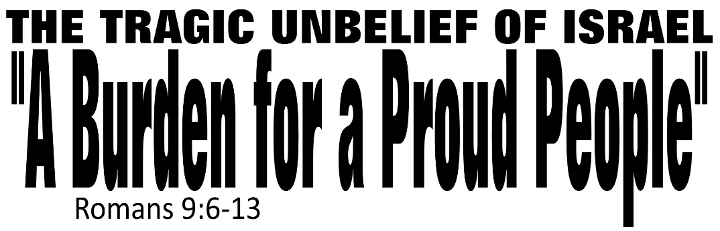

Dr. Joe K. Taylor, Senior Pastor, South Reno Baptist Church, Reno, NV June 14, 2015
All Scriptures are printed verbatim with translations noted. Pew Bible Page Number is 1042-1043.
In the Study Verse Section, God’s Word is printed in regular faced text with Pastor Joe’s commentary in the smaller faced text.
Biblical words, underlined with dots, are explained in the brackets.

1. The Apostle Paul had a great burden for Israel’s unbelief in Christ.
2. He was motivated by a marked obligation.
3. He felt Israel had a missed opportunity to find Christ.
4. He made a magnificent observation about who Christ was.
5. Question: Do you have a heart (like Paul did) for those without Christ?

Why was Paul burdened for Israel?
1. There were proud about their _____________.
Romans 9:6–10, HCSB - ⁶ But it is not [means ‘not in any way, shape or form’] as though the word of God [God’s promises to Israel] has failed [meaning fallen, stumbled, useless]. For not all who are descended from Israel [Israel means “governed by God”—used here as a prepositional object] are Israel [used has as a predicate nominative; meaning not everyone who is ‘governed by God’ is truly governed by God’]. ⁷ Neither are they all children [of God] because they are Abraham’s descendants [ie., physical birth does not save anybody; it’s why Jesus said to Nicodemus, “You must be born again.”]. On the contrary, your offspring will be traced through Isaac [not Ishmael]. ⁸ That is, it is not the children by physical descent who are God’s children, but the children of the promise lit., of faith] are considered to be the offspring. ⁹ For this is the statement of the promise: At this time I will come, and Sarah will have a son. [Ishmael was of the flesh but Isaac was of the faith. ¹⁰ And not only that, but also Rebekah received a promise when she became pregnant by one man, our ancestor Isaac.
“Family does not save you.”
2. There were proud about their _____________.
Romans 9:10-11, HCSB - ¹⁰ And not only that, but also Rebekah received a promise when she became pregnant by one man, our ancestor Isaac. ¹¹ For though her sons [Jacob and Esau] had not been born yet or done anything good or bad, so that God’s purpose [not the common word for “purpose”, this word means “something before, to openly display something—God’s purpose is openly set before us] according to election [lit, “selected”—it speaks of god’s sovereignty; “We did not chose God, He chose us.” Election refers to God’s determination to distribute blessing apart from man’s work] might stand…
“Fruit does not save you.”

3. They misunderstood God’s purpose.
Romans 9:11–13, HCSB - ¹¹ For though her sons had not been born yet or done anything good or bad, so that God’s purpose according to election might stand— ¹² not from works but from the One who calls—she was told: The older will serve the younger. ¹³ As it is written: I have loved [present tense, the root word means “to have mercy” on] Jacob, but I have hated [now in future tense, the root word means “to pity”] Esau. [The use of future tense leads most biblical scholars to believe that God pitied/hated the decedents of Esau who were evil before God’s sight.]
“Faith does save you.”
Pastor Joe Says…  Pastor Joe as drawn by world renown artist Angelo Carlini. | “It’s not our family (blood line) or our fruit (what we do) that saves us, its our faith in God’s Son, Jesus Christ that saves.”  The true Israel was never a race that shared Abraham’s blood, but people who shared his faith.

Life Application Section

W
hen we study scripture, the main things are the plain things, and the plain things are the main things.” - Dr. Wayne Barber

1. God’s Word will not fail you.

2. God’s faithfulness with not allude you.

3. Like Israel, our pride can keep us from God.

4. The only way to be saved is through Faith in Jesus Christ.

Answers to “A Burden for a Proud People” Message
Dr. Joe K. Taylor, Senior Pastor, South Reno Baptist Church, Reno, NV June 14, 2015

1. Position

2. Performance

