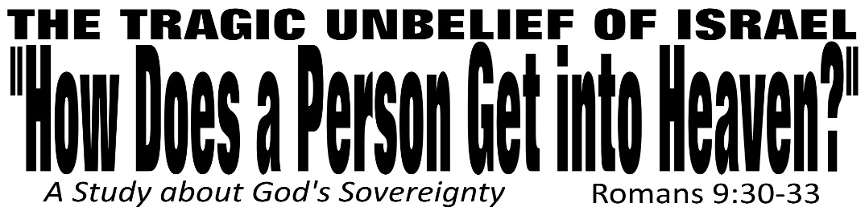

Dr. Joe K. Taylor, Senior Pastor, South Reno Baptist Church, Reno, NV June 28, 2015
All Scriptures are printed verbatim with translations noted. Pew Bible Page Number is 1043.
In the Study Verse Section, God’s Word is printed in regular faced text with Pastor Joe’s commentary in the smaller faced text.
Biblical words, underlined with dots, are explained in the brackets.

1. God’s sovereignty is in keeping with His character of “mercy.”
2. God’s sovereignty is in keeping with His authority.
3. God’s sovereignty is in keeping with His plans.
4. God’s sovereignty should bring anyone to their knees before a Holy God.
5. “All religions in fact DO lead to our God.” (The issue is will we be separated to His right hand (saved) or His left hand (lost for all eternity.)

Life is short and eternity is forever—nothing is more important than understanding the right way to be right with God.

STUDY VERSE SECTION - Romans 9:30–33, HCSB - ³⁰ What should we say then? [ie., conslusional and transitional] Gentiles [ie., non-Jews], who did not pursue righteousness, have obtained [Gk: καταλαμβάνω kata-lam-BANō, means “to receive something you weren’t looking for”] righteousness—namely the righteousness that comes from faith [Gk: πίστις, pis-tus, means “to have a strong confidence or reliance upon something or someone”]. ³¹ But Israel, pursuing [διώκω, diō-kō, means to “follow after something without grasping it”] the law for righteousness, has not achieved the righteousness of the law. ³² Why is that? Because they did not pursue it by faith, but as if it were by [their] works. They stumbled over the stumbling stone. ³³ As it is written: Look! I am putting a stone [Gk: λίθος lith-os, “a small rock” (treated metaphorically as truth)] in Zion to stumble [Gk: προσκόπτω, pro-SKOPT-o, means “to dash your foot into a hard object and trip”] over and a rock [Gk: πέτρα, pet-ra, meaning “a ledge or large rock foundation displaced from its place of origin”] to trip over, yet the one who believes [Gk: πιστεύω, pis-TEE-o, means “to have a strong confidence or reliance upon something or someone identified”] on Him will not be put to shame [lit., “disgraced”].

• Matthew 16:13-19

• I Corinthians 1:23

The Right and Wrong Ways to Come to God
1. To approach God through your personal effort is placing your faith in yourself. (This will cause you to stumble over Christ and be lost.)
Romans 9:31–33, NLT - ³¹ But the people of Israel, who tried so hard to get right with God by keeping the law, never succeeded. ³² Why not? Because they were trying to get right with God by keeping the law instead of by trusting in Him. They stumbled over the great rock in their path. ³³ God warned them of this in the Scriptures when he said, “I am placing a stone in Jerusalem that makes people stumble, a rock that makes them fall. But anyone who trusts in Him will never be disgraced.”

• Faith in yourself is the fundamental problem with it comes to believing in the Gospel.

2. To approach God through faith in Christ results in being right with God. (This will cause you to be saved by Christ’s work—not your work.)
Romans 9:30, NLT - ³⁰ What does all this mean? Even though the Gentiles were not trying to follow God’s standards, they were made right with God. And it was by faith that this took place…³³ “…anyone who trusts in Him will never be disgraced.”

• Faith in God means we must renounce our merit and our works as the basis for approaching God. We must entrust our right standing with God totally to the merits and substitutionary death of Jesus Christ on our behalf.

Through faith in God, the Gentiles found righteousness without even seeking it. Through faith in the law, Israel did not find righteousness even after seeking it.

Life Application Section

“Christ will either be a stepping stone or a stumbling block.”
Option A – Christ can be a rock in which you believe and build your life. That’s how you get into heaven—through faith in Christ!
Option B – Christ will be a stone to stumble over and a rock of offence to your sinful pride. Don’t stumble over Him by trusting in your good works to save you. (The religions of the world teach you are saved by works—but it’s not so.)

