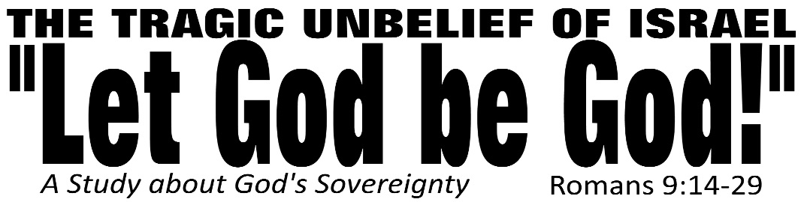

Dr. Joe K. Taylor, Senior Pastor, South Reno Baptist Church, Reno, NV June 19, 2015
All Scriptures are printed verbatim with translations noted. Pew Bible Page Number is 1043.
In the Study Verse Section, God’s Word is printed in regular faced text with Pastor Joe’s commentary in the smaller faced text.
Biblical words, underlined with dots, are explained in the brackets.

1. Family does not save you. “…not children of physical decent” v. 8
2. Fruit does not save you. “…[They had done] anything good or bad.” v. 11
3. Faith (in God) does save us. “…not from works but from God…”
4. We must understand God’s Sovereignty and Man’s Responsibility is the salvation process.

Three Inescapable Truths about
God’s Sovereignty

1. God’s sovereignty is in keeping with His
character.
Romans 9:14–18, HCSB - ¹⁴ What should we say then? Is there injustice with God? Absolutely not! ¹⁵ For He tells Moses: I will show mercy to whom I will show mercy [Gk: ἐλεέω, el-EE-o, lit., to have sympathy to the point of action], and I will have compassion [lot., pity] on whom I will have compassion. ¹⁶ So then it does not depend on human will or effort but on God who shows mercy. ¹⁷ For the Scripture tells Pharaoh: I raised you up for this reason so that I may display My power in you and that My name may be proclaimed in all the earth. ¹⁸ So then, He shows mercy to those He wants to, and He hardens [Gk: σκληρύνω, sklu-ROO-o, “’to make hard or stiff”; used here in “passive voice” (God finishes what we started”) those He wants to harden.
• God determined to pardon sinful Israel with underserved grace. (vv. 15-16)
• God determined to pardon sinful Pharaoh with deserved judgement (vv. 17-18)
“Why does a sovereign God pour His mercy out for anyone?”
2. God’s sovereignty is in keeping with His
authority.
Romans 9:19–24, HCSB - ¹⁹ You will say to me, therefore, “Why then does He still find fault? For who can resist His will?” ²⁰ But who are you, a mere man, to talk back to God? Will what is formed say to the one who formed it, “Why did you make me like this?” ²¹ Or has the potter no right over the clay, to make from the same lump one piece of pottery for honor and another for dishonor? ²² And what if God, desiring to display His wrath and to make His power known, endured with much patience objects of wrath ready for destruction? ²³ And what if He did this to make known the riches of His glory on objects of mercy that He prepared beforehand for glory — ²⁴ on us, the ones He also called, not only from the Jews but also from the Gentiles?
• As a potter creates vessels, God creates nations (vv. 14, 21-22)
• As a potter controls vessels, God controls nations (vv. 23-24)

3. God’s sovereignty is in keeping with His
Plans.
Romans 9:25–29, HCSB - ²⁵ As He also says in Hosea: I will call Not My People, My People, and she who is Unloved, Beloved. ²⁶ And it will be in the place where they were told, you are not My people, there they will be called sons of the living God. ²⁷ But Isaiah cries out concerning Israel: Though the number of Israel’s sons is like the sand of the sea, only the remnant will be saved; ²⁸ for the Lord will execute His sentence completely and decisively on the earth. ²⁹ And just as Isaiah predicted: If the Lord of Hosts had not left us offspring, we would have become like Sodom, and we would have been made like Gomorrah.
• The Example of Hosea – This OT prophet prophesied that God would not limit His grace to Israel but would save repenting Gentile people (Hosea called the repenting Gentiles “Children of the living God.”) (cf., Hox. 2:23; 1:10)

• The Example of Isaiah – This OT prophet is quoted by Paul (here) to demonstrate God’s sovereignty concerning Israel. (Isaiah prophesied that only a small remnant will be saved from Israel and that apart from God’s mercy and grace, all of Israel would have perished.) (cf., Isa. 1:9ff, 9:29ff)

Sovereign God is our maker and He can use any and every circumstance to accomplish His plan.
APPLICATION: Paul wrote Romans 9 to bring Israel to their knees and repent.
God’s sovereignty is should bring us to our knees! Let God be God in You.

