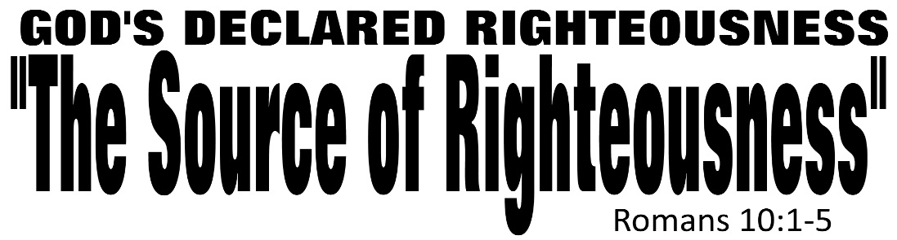

Dr. Joe K. Taylor, Senior Pastor, South Reno Baptist Church, Reno, NV August 9, 2015
All Scriptures are printed verbatim with translations noted. Pew Bible Page Number is 1043-1044.
In the Study Verse Section, God’s Word is printed in regular faced text with Pastor Joe’s commentary in the smaller faced text.
Biblical words, underlined with dots, are explained in the brackets. Pastor Joe’s Email: Joe@southreno.com

1. Life is short and eternity is forever—nothing is more important than understanding the right way to be right with God.
2. To approach God through your personal effort is placing your faith in yourself.
3. To approach God through faith in Christ results in being right with God.
4. The ONLY WAY to be right with God is by being right with Jesus (ie., surrender).

1. The Prayer for God’s Righteousness.
Romans 10:1–2, HCSB - ¹ Brothers, my heart’s desire and prayer to God concerning them is for their salvation [Gk: σωτηρία, (so-TEAR-ee-a) “the state of being delivered or preserved from judgment”; it refers to ‘being saved’]! ² I can testify about them that they have zeal for God, but not according to knowledge [Gk: ἐπίγνωσις (e-pig-no-sis) “to lack a comprehension of what is required”; they did not realize what God would require of them—perfection!].
Romans 10:1–2, NLT - ¹ Dear brothers and sisters, the longing of my heart and my prayer to God is for the people of Israel to be saved. ² I know what enthusiasm they have for God, but it is misdirected zeal.

2. The Source of God’s Righteousness.
Romans 10:3–4, HCSB - ³ Because they disregarded the righteousness from God and attempted to establish their own righteousness, they have not submitted themselves to God’s righteousness. ⁴ For Christ is the end of the law for righteousness to everyone who believes.
Romans 10:4, NLT - ⁴ For Christ has already accomplished the purpose for which the law was given. As a result, all who believe in Him are made right with God.
They had zeal without knowledge and works without faith.
Righteousness
Word Study: “Righteousness” – Gk: δικαιοσύνη (dee-kio-ah-SOON-a); used 35 times in Romans, it’s the focus of Chapter 10; “A status of legal rectitude that satisfies the highest moral requirements of God’s character” (TDNT); while the person seeking salvation through the law would be forever trying to keep it (10:5), the salvation Christ offers is not in some unattainable place; it as near as your hearts. It is God’s declaration of righteousness over all who surrender their lives—by faith—to Him. It is when God treats the saved sinner as if they had never sinned. It’s possible because the blood of Christ covers our sins completely.

Etymology: The Greek work, δικαιοσύνη, derives from δικαι (di-kee) Lit. “right” or “perfect” meaning “righteousness”; and σύνη (SOON-a), an ending developed by the Athenians (cf., Acts 17) to describe “the highest level of something only a god could attain,” thus this word means “God’s righteousness” that man can’t reach and only God can give. (Application: Man can never be this ‘right’ or this ‘perfect’ but God can ‘declare us right’ because of His work on the cross.)

Life Application Section

God’s Forgiveness
A. The blood of Jesus Christ cleanses us from all sin.
1 John 1:7, NASB95 - ⁷ but if we walk in the Light…the blood of Jesus His Son cleanses us from all sin.
B. Believers in Christ will be as made white as snow.
Isaiah 1:18, NASB95 - ¹⁸ “Come now, and let us reason together,” Says the Lord, “Though your sins are as scarlet, They will be as white as snow; Though they are red like crimson, They will be like wool.
C. God forgives and forgets our sins.
Isaiah 43:25, NASB95 - ²⁵ “I, even I, am the one who wipes out your transgressions for My own sake, And I will not remember your sins.
Psalm 103:12, NLT - ¹² He has removed our sins as far from us as the east is from the west.
D. God’s forgiveness is possible ONLY because of Christ’s death on the cross.
Romans 3:25–26, NLT - ²⁵ God presented Jesus as the sacrifice for sin. People are made right with God when they believe that Jesus sacrificed His life, shedding His blood. This sacrifice shows that God was being fair when He held back and did not punish those who sinned in times past, ²⁶ for He was looking ahead and including them in what He would do in this present time. God did this to demonstrate His righteousness, for He Himself is fair and just, and He declares sinners to be right in His sight when they believe in Jesus.

I
f we are going to persevere as committed disciples of Jesus Christ over the course of our lives, we must always keep the gospel of God’s forgiveness through Christ before us.
– Jerry Bridges

