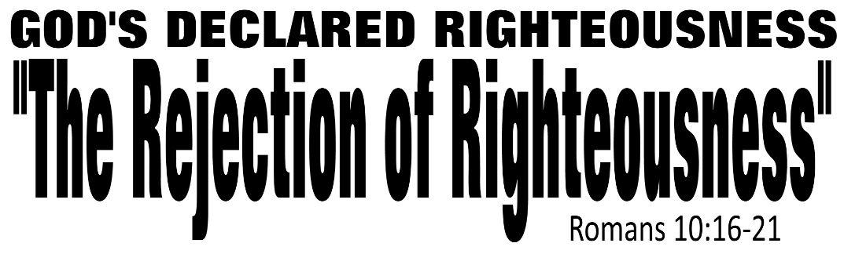

Dr. Joe K. Taylor, Senior Pastor, South Reno Baptist Church, Reno, NV September 7, 2015
All Scriptures are printed verbatim with translations noted. Pew Bible Page Number is 1044.
In the Study Verse Section, God’s Word is printed in regular faced text with Pastor Joe’s commentary in the smaller faced text.
Biblical words, underlined with dots, are explained in the brackets. Pastor Joe’s email is Joe@southreno.com

- God, in His sovereignty (Chapter 9), gives all men both the responsibility and privilege (Chapter 10) to say “yes” to His Lordship in their lives.
- The Scope of God’s Righteousness is both impartial and universal.
- The Presentation of God’s Righteousness is most important because a person is saved with he/she puts their faith in Jesus Christ. That ‘faith’ comes from hearing and the unbeliever can’t hear unless someone tells them.

- The Rejection of God’s Righteousness.

- Israel has heard the “good news.”
Romans 10:18, HCSB - ¹⁸ But I ask, “Did they not hear?” Yes, they did: Their voice has gone out to all the earth, and their words to the ends of the inhabited world.
Romans 10:18, NLT - ¹⁸ But I ask, have the people of Israel actually heard the message? Yes, they have: “The message has gone throughout the earth, and the words to all the world.”
- Israel has rejected the “good news.”
Isaiah predicted this
Romans 10:16–17, HCSB - ¹⁶ But all did not obey the gospel. For Isaiah says, Lord, who has believed our message? ¹⁷ So faith comes from what is heard, and what is heard comes through the message about Christ.
Romans 10:20–21, HCSB - ²⁰ And Isaiah says boldly: I was found by those who were not looking for Me; I revealed Myself to those who were not asking for Me. ²¹ But to Israel he says: All day long I have spread out My hands to a disobedient and defiant people. (cf., Isaiah 53:1; 65:1–2.)
Moses predicted this
Romans 10:19, HCSB - ¹⁹ But I ask, “Did Israel not understand?” First, Moses said: I will make you jealous of those who are not a nation [ie., That’s us]; I will make you angry by a nation that lacks understanding. (cf., Deuteronomy 32:21.)
Because the work of the Cross is complete, all that is left for us to do is to respond and accept the Lord by faith (not works). Then, and only then can God declare us righteous.
Life Application Section

For Those Seriously Considering Christ
A. Only Christ gives us grace for the disappointments of life.
B. Only Christ gives us strength for the trials of life.
C. Only Christ gives us hope for the end of life.
D. “Only Christ can forgive our sins and declare us righteous”

For Those NOT Seriously Considering Christ
A. Not everybody will be saved (Matthew 13:24-30).
B. Many people will perish (Matthew 7:13)
C. Some who think they are saved will be lost (Matthew 7:21)
D. There is no salvation after death (Hebrews 9:27)
E. This very moment may be your last opportunity to surrender to Christ.
● You may die
● Christ may return
● His Spirit may ‘move on’

