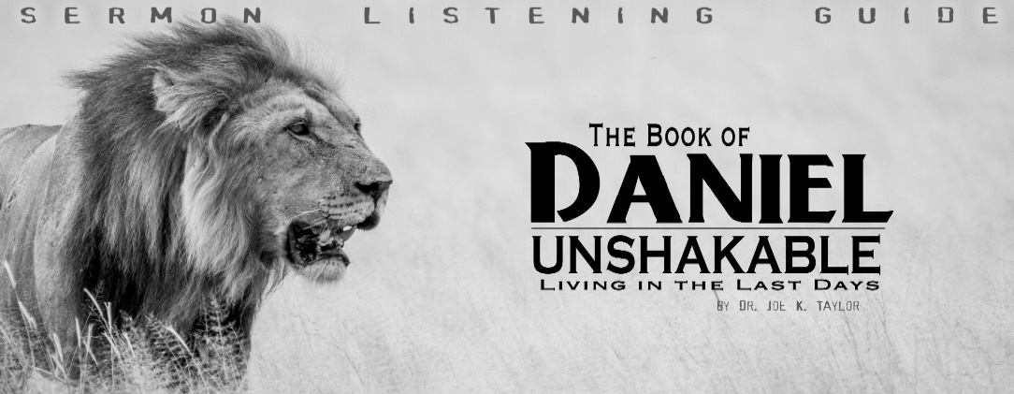
Dr. Joe K. Taylor, Senior Pastor, South Reno Baptist Church, Reno, Nevada June 9, 2019
All Scriptures are printed verbatim with translations noted. When Pastor Joe’s commentary is added, God’s Word will be printed in regular faced text with commentary in the smaller faced text. Biblical words, underlined with dots, are explained in the brackets.
Pastor Joe’s email is Joe@southreno.com. This passage can be found in the Pew Bible, in the Old Testament on pages 632.
“Dare to be a Daniel, Dare to stand alone;
Dare to have a purpose firm, Dare to make it known.”
-Phillip Paul Bliss, Dare to be a Daniel, (Circa 1873).
Study section

Learning Truth the Hard Way\

1. The _______________ after the Experience.
Daniel 4:34, NASB95 - ³⁴ “But at the end of that period, I, Nebuchadnezzar, raised my eyes toward heaven and my reason returned to me, and I blessed the Most High and praised and honored Him who lives forever….
Daniel 4:36, NASB95 - ³⁶ “At that time my reason returned to me. And my majesty and splendor were restored to me for the glory of my kingdom, and my counselors and my nobles began seeking me out; so I was reestablished in my sovereignty, and surpassing greatness was added to me.
His Mentality Returned (Health) His Monarchy Returned (Honor)
2. The _______________ from the Experience.
Daniel 4:34, NASB95 - ³⁴ “But at the end of that period, I, Nebuchadnezzar, raised my eyes toward heaven and my reason returned to me, and I blessed the Most High and praised and honored Him who lives forever; For His dominion is an everlasting dominion, And His kingdom endures from generation to generation.
A. The Person he praised: “I Blessed the Most High…” v. 34
B. The power he praised: “His dominion is…everlasting.” v. 34.
C. The Permanence he praised: ”[It is God]…who lives forever; For His dominion is an everlasting dominion, And His kingdom endures from generation to generation.” v. 34.

3. The _______________ because of the Experience.
Daniel 4:37, NASB95 - ³⁷ “Now I, Nebuchadnezzar, praise, exalt and honor the King of heaven, for all His works are true and His ways just, and He is able to humble those who walk in pride.”
A. He confesses the sovereignty of God: vv. 34-35
B. He confesses the insufficiency of man: v. 35
C. He confesses the attributes of God: v. 37
D. He recognizes God will resist the proud; give grace to the humble. V. 37

Life Application Section

Lessons from a Changed man

Point: God is Sovereign!

A. No one is more free than the one who surrenders to God’s sovereignty.
B. To ignore God’s sovereignty is to exalt human pseudo-significance.
The Bible teaches both God’s sovereignty and man’s responsibility. To ignore God’s sovereignty is to exalt human responsibility and make man his/her own savior; to deny man’s responsibility is to make man a robot without accountability.
C. Practical implications of God’s Sovereignty:
Confidence in God’s ultimate victory and Satan’s eventual defeat.
Comfort in the midst of trials and affiliations.
Complete sense of security (God is sovereign and sufficient; man is insufficient.)
Answers: 1. Progress, 2. Praise, 3. Proclamation.

