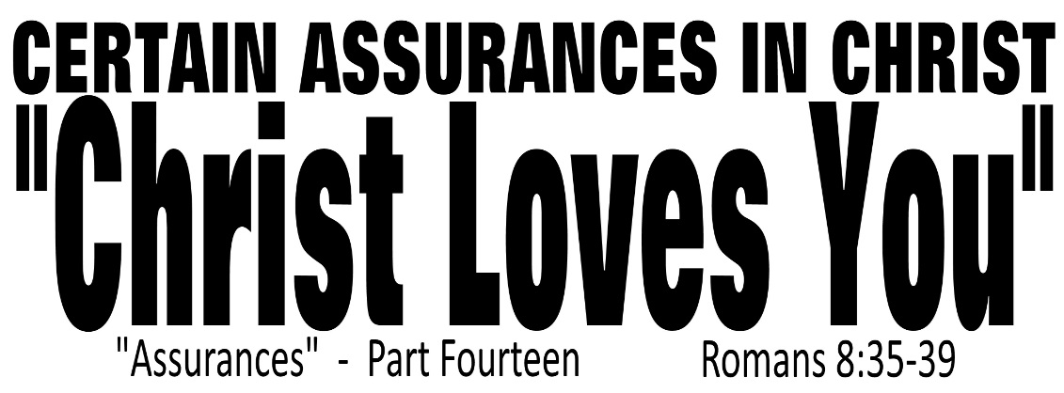

Dr. Joe K. Taylor, Senior Pastor, South Reno Baptist Church, Reno, NV April 26, 2015
All Scriptures are printed verbatim with translations noted. Pew Bible Page Number is 1042.
In the Study Verse Section, God’s Word is printed in regular faced text with Pastor Joe’s commentary in the smaller faced text.
Biblical words, underlined with dots, are explained in the brackets.

1. We are saved by works after all—His works, not ours.
2. We must remember the price He paid at the cross, the power He displayed at the tomb and the position He holds at the throne.
3. As a follower of Christ, you can be certain that Christ’s work will save.
4. Right now Christ in praying for you.

STUDY VERSE SECTION - Romans 8:35–39, HCSB - ³⁵ Who [this interrogative Greek pronoun τίς can be understood as “what”] can separate [lit., to divorce or to amputate] us from the love [Gk: ἀγάπη, a-ga-pē, the highest level of love—it is sacrificial in nature] of Christ? Can affliction [lit., to be squeezed or to feel pressure] or anguish [lit., a narrow place] or persecution [ie., suffering inflicted on us because of our dedication to Jesus Christ] or famine [lit., a lack of necessary resources as a byproduct of persecution] or nakedness [lit., a lack of clothing or to be in a state of destitution also due to persecution] or danger [lit., peril—the threat of imminent and awful danger] or sword [lit., a dagger—used as a reference to the threat of murder]? ³⁶ As it is written [in Ps. 44:22]: Because of You we are being put to death all day long; we are counted as sheep to be slaughtered. [VERY IMPORTANT: The cost of faithfulness to God has always been high]. ³⁷No, in all these things we are more than victorious [Gk: ὑπερνικάω, hyper-ni-kio, lit., hyper victor, used here in future tense—so certain of this “victory” we speak as if it’s already come true ie., we may not win every battle here on Earth and if we don’t’ understand this, we will be frustrated, disillusioned, embittered, and discouraged, but in the end times, we will win—Christ will win!); for as one scholar stated, “we are overwhelmingly conquerors” (ATR)] through [ie., because of] Him who loved us. ³⁸ For I am persuaded that not even death or life, angels [rf., fallen angels—demons] or rulers, [rf., government officials—good and bad] things present or things to come, hostile powers, ³⁹ height or depth, or any other created thing will have the power to separate us from the love of God that is in Christ Jesus our Lord!
Secured by the Love of Christ
1. His love is ____________________.
Romans 8:35–36, NLT - ³⁵ Can anything ever separate us from Christ’s love? Does it mean he no longer loves us if we have trouble or calamity, or are persecuted, or hungry, or destitute, or in danger, or threatened with death? ³⁶ (As the Scriptures say, “For your sake we are killed every day; we are being slaughtered like sheep.”) ³⁷ No….
Hebrews 13:5, NIV84 - ⁵ …God has said, “Never will I leave you; never will I forsake you.”
2. His love is ____________________.
Romans 8:37, NLT - ³⁷ No, despite all these things, overwhelming victory is ours through Christ, who loved us.
• God does not shelter us from difficulties in life (Rom. 5:3-7).
• God assures us that our difficulties are working for us not against us (Rom. 8:28).
• God permits difficulties for our good and His glory (Rom. 8:36).
• God gives us the ability to overcome despite our difficulties (Rom. 8:37).
3. His love is ____________________.
Romans 8:38–39, NLT - ³⁸ And I am convinced that nothing can ever separate us from God’s love. Neither death nor life, neither angels nor demons, neither our fears for today nor our worries about tomorrow—not even the powers of hell can separate us from God’s love. ³⁹ No power in the sky above or in the earth below—indeed, nothing in all creation will ever be able to separate us from the love of God that is revealed in Christ Jesus our Lord.

As a follower of Christ, you can be certain that Christ has and always will love you.

A
review of this wonderful chapter shows that the Christian is completely victorious. We are free from judgment because Christ died for us and we have His righteousness. We are free from defeat because Christ lives in us by His Spirit and we share His life. We are free from discouragement because Christ is coming for us and we shall share His glory. We are free from fear because Christ intercedes for us and we cannot be separated from His love. This chapter begins with “No condemnation!” and ends with “No separation!”…If God indeed loves us and if God indeed be for us, who really can be against us!
-Dr. Warren Wiersbe
____________________
Wiersbe, W. W. (1996). The Bible Exposition Commentary (Vol. 1, pp. 542–543). Wheaton, IL: Victor Books.

Answers to “Christ Loves You” Message
Dr. Joe K. Taylor, Senior Pastor, South Reno Baptist Church, Reno, NV April 26, 2015

1. Enduring
2. Enabling
3. Everlasting

Wiersbe, W. W. (1996). The Bible Exposition Commentary (Vol. 1, pp. 542–543). Wheaton, IL: Victor Books.

